Pre-Closing Possession License Agreement

This agreement is made this day of , 200 , between

(hereafter called the “Seller”) and

(hereafter called the “Purchaser”).

The “Purchaser” requests possession of the premises ______________________________________
prior to the actual closing of the title as defined in the contract between the parties, dated
.

Notwithstanding the delivery of possession stated and anticipated under the contract, the “Seller” in furtherance of the goals of the contract and in the spirit of cooperation agrees to allow the “Purchaser” possession of the premises as of the ___________________________ day of ___________, 20____ .

This occupancy shall be only a license and shall in no way create a landlord-tenant relationship.

“Purchaser” will pay “Seller” the sum of $_________ per day in advance prior to the date of possession.

These payments will continue to be due through midnight of the day prior to the actual closing.

Any surplus shall be credited to “Purchaser” at closing; any deficiency shall be paid to “Seller” at closing as part of the purchase price.

“Purchaser” shall maintain fire insurance in the amount of $ ___________________________ .

“Purchaser”, subject to an inspection prior to possession, agrees to accept premises in “as-is condition” and, if for any reason closing does not occur, shall restore premises to their existing condition as of the date of possession.

“Purchaser” shall keep the premises in good condition. “Seller”, upon reasonable notice, shall have unlimited access to inspect the premises and to perform maintenance or necessary repairs neglected by the “Purchaser” and to deduct the amount expended from the contract deposit.

The rights of “Purchaser” shall not be assignable.

The original contract, except as modified by this agreement, remains in full force and effect.

___________________________________ ______________________________
Purchaser Seller

___________________________________ ______________________________
Purchaser Seller

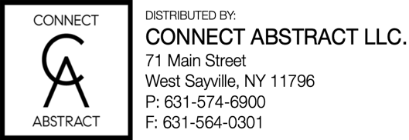
DISTRIBUTED BY

MacGregor Abstract Corporation
800-820-1700 FAX: 866-820-1900
DISTRIBUTED BY

The Judicial Title Insurance Agency LLC
800-281-TITLE (8485) FAX: 800-FAX-9396

